Grammar Correction Using Deep Learning BART Model

Gaddam Saranya¹, Garnepudi Sagarbabu², Nallamsetty Vinay³, Pikkili Venkatesh⁴, Pideka Kundil Abhilash⁵, Nara Kalyani⁶, Syed Rizwana⁷
1,2,3,4,7Department of Computer Science and Engineering,
Narasaraopeta Engineering College (Autonomous), Narasaraopet, Andhra Pradesh, India.
5Department of Information Technology, GRIET, Bachupally, Hyderabad, Telangana, India.
6Department of Computer Science and Engineering,
G. Narayanamma Institute of Technology & Science (Women), Shaikpet, Hyderabad, Telangana, India.

1gaddamsaranya@gmail.com, ²sagarbabugarnepudi5@gmail.com, ³nvinay3333@gmail.com, 4venkateshpikkili33@gmail.com, ⁵abhilash848@grietcollege.com,
6nara.kalyani@gnits.ac.in, ⁷syedrizwananrt@gmail.com

Abstract—This paper presents a transformer-based frame- work for grammatical error correction (GEC) that integrates lightweight error detection with fluent correction. Unlike existing single-stage models, the proposed system employs pre-classifiers (DistilBERT, RoBERTa, and DeBERTa) to detect potential errors, followed by a BART-based corrector enhanced with a super- vised copy mechanism. This design ensures that only erroneous segments are modified, reducing overcorrection and preserving sentence fluency. The novelty of this work lies in the two- stage architecture, which combines efficiency with accuracy, and demonstrates scalability for real-world deployment. Exper- imental results on benchmark datasets such as Lang-8 and JFLEG show that the system outperforms baseline models in BLEU, F1, and MCC scores. These results confirm that the proposed approach provides both high-quality corrections and computational efficiency, making it a promising direction for practical grammar assistance applications.
Index Terms—Grammatical Error Correction, Deep Learning, Transformers, BART, Lang-8, BLEU, MCC, Natural Language Processing, Neural Networks, Educational AI

- Introduction
Written communication has become a central part of daily life through emails, messages, and online platforms. However, many individuals, particularly students and non-native English speakers, face difficulties in producing grammatically correct sentences [1]. Even minor grammatical errors can reduce clar- ity and overall quality of writing, creating a need for intelligent tools capable of automatically detecting and correcting such errors.
Earlier grammar correction systems relied on rule-based approaches [2], which were difficult to update and unable to handle complex or informal language. Later, statistical and translation-based methods were introduced [6], but they often made unnecessary changes and produced corrections that sounded unnatural [16].
To address these limitations, we propose a grammar cor- rection framework built on modern deep learning techniques.
The system employs BART [17] for sentence-level rewrit- ing, enhanced with a supervised copy mechanism [10], [21] that preserves correct tokens and modifies only erroneous ones. Before correction, errors are detected using lightweight transformer classifiers—DistilBERT [18], RoBERTa [19], and DeBERTa [20]. Training and evaluation are performed on large-scale learner corpora, including Lang-8 and JFLEG [3], [7], which provide a wide range of grammatical errors and high-quality corrections.
The contributions of this paper are summarized as follows:
- A hybrid grammatical error correction (GEC) system that combines token-level error detection with sequence-to- sequence correction.
- A data preprocessing and augmentation pipeline to im- prove training quality and generalization.
- Dual evaluation metrics—BLEU for fluency [7] and Matthews Correlation Coefficient (MCC) for accu- racy—providing a balanced evaluation.
- Visual tools and an interactive Gradio-based interface for real-time testing and qualitative analysis.
A. Novelty of This Work
most prior research that treats error detection and correction as separate tasks, our work integrates both into a single end- to-end pipeline. The novelty lies in three aspects:
- Unified framework: Joint detection and correction within one system, reducing complexity and enabling real-time usability.
- Hybrid detection strategy: Leveraging multiple pre- trained transformers (DistilBERT, RoBERTa, DeBERTa) for robust token-level error detection.
- Fluent minimal-edit correction: Using BART with a su- pervised copy mechanism to preserve correct tokens and minimize unnecessary rewriting, ensuring more natural corrections.

This design balances accuracy, efficiency, and practical deployment, setting our framework apart from existing GEC approaches.
- Related Work
Research on Grammatical Error Correction (GEC) has evolved significantly over the past few decades. Early systems primarily used rule-based approaches, relying on predefined grammar rules to detect and correct errors. While effective for simple mistakes, these systems struggled with informal or complex sentences. This limitation led to the development of data-driven approaches that leverage large corpora to identify common error patterns [2].
Grammatical errors are particularly common in student writ- ing. Neupane [1] analyzed student compositions and observed recurring mistakes, highlighting the need for robust GEC systems in real-world contexts. The creation of large datasets such as Lang-8 [25] and JFLEG [4] has further advanced the field, allowing models to learn both error detection and natural sentence rewriting.
To improve correction accuracy, various strategies have been explored:
Minimal-edit and copy-based mechanisms: Li et al. [3] proposed minimal-edit approaches, while Zhao et al. [21] introduced a copy-augmented architecture pre-trained with un- labeled data to improve GEC. Al-Sabahi and Yang [25] further enhanced this concept with a supervised copy mechanism that preserves correct tokens during correction. Xu et al. [11] also used attention-based copying to maintain sentence fluency and accuracy.
Evaluation metrics: While traditional metrics such as BLEU [22] have been widely used to measure sentence-level alignment, they may not fully capture fluency or error de- tection quality. Matthews Correlation Coefficient (MCC) [23],
[24] has been used to assess token-level error detection per- formance, especially in imbalanced datasets, complementing fluency-focused metrics.
Multilingual and low-resource GEC: Rothe et al. [6] devel- oped multilingual systems capable of handling low-resource languages.
Synthetic data and stepwise correction: Stahlberg et al.
[7] proposed synthetic error generation to reduce reliance on manual annotation, and Awasthi et al. [5] introduced stepwise correction strategies.
The development of attention mechanisms [15] and Trans- formers [12] enabled large-scale models like BART [17], GPT-
3 [13], and T5 [14], which dominate modern GEC tasks. Hierarchical attention mechanisms proposed by Al-Sabahi et al. [?], [16] further enhanced context modeling.
Building on these innovations, our work integrates pre- trained transformer models—DistilBERT [18], RoBERTa [19], and DeBERTa [20]—for token-level error detection, followed by BART [17] for sentence-level correction. The supervised copy mechanism [10], [21], [25] ensures that correct tokens remain unchanged, reducing overcorrection and producing corrections that are both accurate and contextually fluent.
- Methodology
Our proposed system for Grammatical Error Detection and Correction (GED&GEC) is built on a transformer-based sequence-to-sequence framework, with BART as the central model [17]. This section outlines the key steps in our approach, including system design, data preprocessing, training strategy, and evaluation setup. Each step is designed to ensure that the system produces accurate, reliable, and natural corrections.
- System Overview
The pipeline integrates error detection and correction in two stages. First, lightweight transformer models, DistilBERT [18], RoBERTa [19], and DeBERTa [20], act as pre-classifiers to spot tokens likely containing errors. This filtering reduces unnecessary computation and prevents overcorrection. Next, BART generates corrected sentences, guided by a supervised copy mechanism [21] that keeps the correct text while editing only the erroneous parts. This two-stage design ensures both accuracy and fluency in the final output.
- Datasets
We rely on two complementary datasets to train and evaluate the system.
Lang-8 Learner Corpus. : A large-scale dataset of learner- written sentences corrected by native speakers. It exposes the model to diverse, real-world grammar mistakes, making it ideal for pretraining and capturing common learner error patterns.
JFLEG Corpus: Unlike Lang-8 [25], JFLEG [25] empha- sizes both correctness and fluency. Each sentence includes multiple human-written corrections, showcasing different nat- ural ways of rewriting. This diversity is crucial for fine- tuning and assessing whether the model’s outputs are not only grammatically correct but also human-like and readable.
By combining Lang-8’s breadth with JFLEG’s depth, our system learns both error detection and natural rewriting, en- suring corrections are practical for real-world writing.
- Data Preprocessing
Preprocessing ensures data quality and model readiness. Key steps include:
  - Cleaning: Removing any sentence pairs that are empty or incorrectly formatted to ensure data quality.
  - Lowercasing: Converting all text to lowercase to keep the vocabulary simple and consistent.
  - Tokenization: Splitting each sentence into tokens using the BART tokenizer from the Hugging Face Transformers library.
  - Padding and truncation: Shortening or padding sentences to a fixed length of 128 tokens so that all follow the same format.
  - Label formatting: Matching each input sentence with its corrected version to create input–output pairs for training the model.

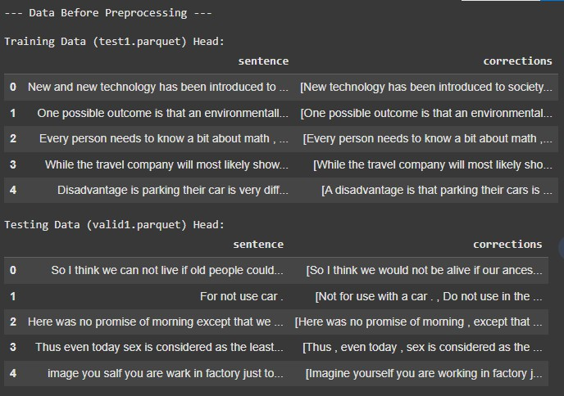

Fig. 1. Data before and after preprocessing.

Fig. 1 shows the data before and after preprocessing. If any errors are present in the data, they can cause incorrect outputs, so preprocessing is applied on the JFLEG dataset.
- Model Architecture
Our main model is the base version of BART, a denoising autoencoder that blends a bidirectional encoder with an autore- gressive decoder [17]. The encoder takes in the error-filled sentence, while the decoder generates the corrected version. BART works particularly well for grammar correction because it can understand long-range context and make flexible edits to the sentence.
To boost its accuracy even further, we add a supervised copy mechanism [21]. This feature teaches the model to directly copy words from the original sentence when they do not need fixing. As a result, the model avoids making unnecessary changes and produces more natural, fluent corrections.
- Training Configuration
The training was carried out on a cloud-based Google Colab environment using PyTorch and Hugging Face libraries [?]. Key hyperparameters include:
  - Batch size: 8
  - Epochs: 1
  - Optimizer: AdamW with weight decay to help prevent overfitting and improve generalization.
  - Learning rate: 2e-5
  - Evaluation strategy: Validation at the end of each epoch
  - Loss function: CrossEntropyLoss applied to token-level outputs
During training, early stopping and checkpointing are em- ployed to prevent overfitting and retain the best model based on validation loss.
- Evaluation Metrics
We assess our model using both fluency and classification- oriented metrics:
  - BLEU score, which measures alignment of generated sentences with reference corrections [22].
  - Matthews Correlation Coefficient (MCC), which evalu- ates the binary classification performance of error detec- tion, especially under imbalanced conditions [23].
These metrics provide a balanced view of both the linguistic quality of corrections and the precision of the error identifica- tion process.
- Visualization and Interface
For qualitative evaluation, a Gradio interface is deployed that allows users to input custom sentences and view corrected outputs. This interface aids in real-time inspection and educa- tional deployment of the model.
- System Architecture and Model Design
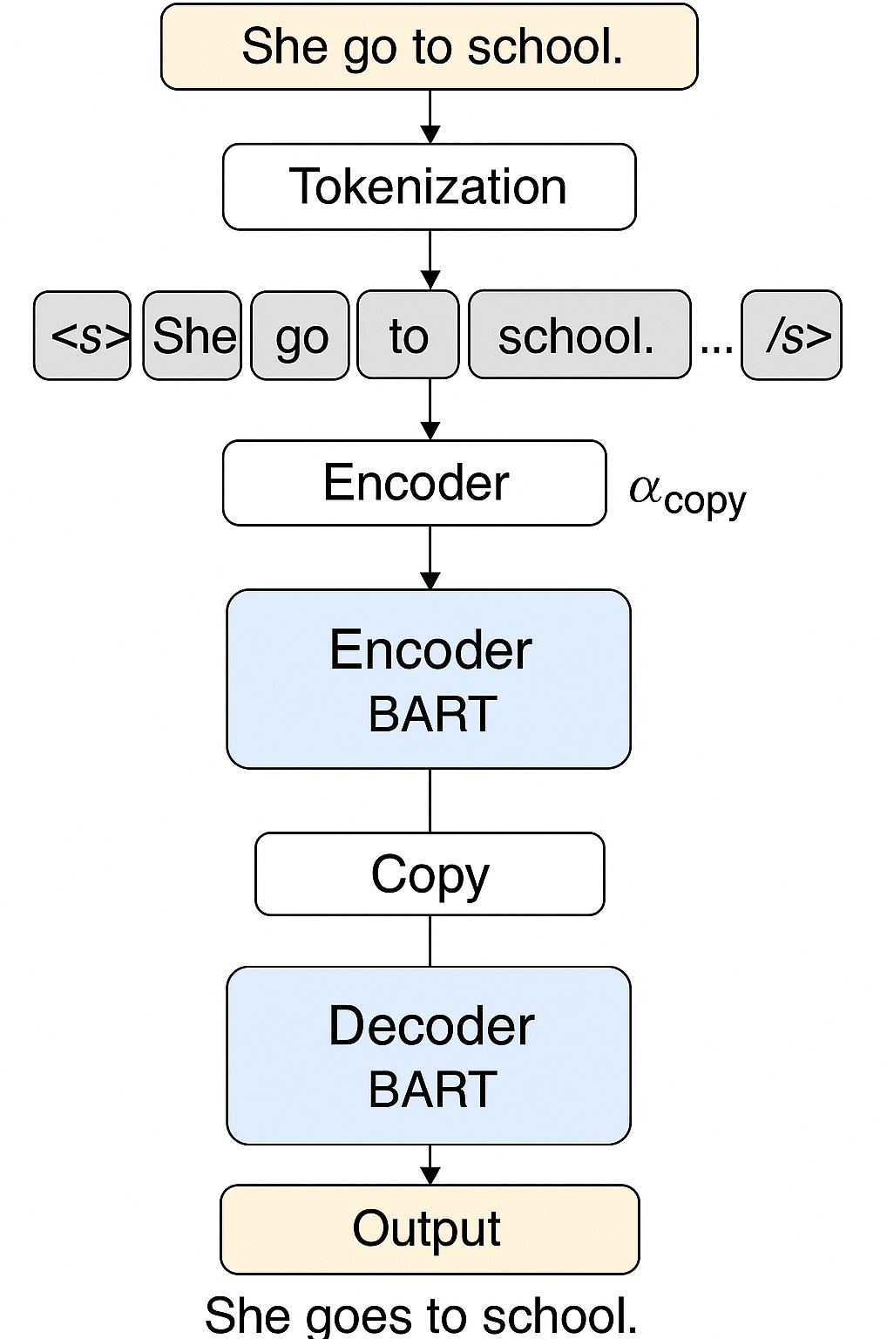

Fig. 2. Detailed architecture of the GEC system.

The design of our grammar correction system is built around a transformer-based sequence-to-sequence model, specifically using the BART architecture. As shown in Fig. 2, the entire correction process is carried out end-to-end, with a supervised copy mechanism integrated into BART to improve accuracy and control.
The model processes the input sentence through the follow- ing stages:

- Tokenization: Converts raw input (e.g., “She want to fly”) into BART-compatible tokens.
- Encoder: Processes tokens contextually using multi- head self-attention layers to capture syntactic and se- mantic relationships.
- Supervised copy mechanism: Introduces a guided at- tention layer trained to distinguish between correct and incorrect tokens, assigning an α_{copy} value to influence token treatment.
- Decoder: Uses encoder outputs and copy attention weights to generate corrected output sequentially.
- Postprocessing: Detokenizes and reassembles the output into a fluent and grammatically correct sentence (e.g., “She wants to fly”).
This layered pipeline enhances both precision and inter- pretability. The supervised copy mechanism empowers the model to explicitly focus on correction-worthy tokens rather than altering the entire sequence indiscriminately.
In addition to BART, we examined and compared alternate model architectures, including:
  - GECToR (BERT-based tagger): Excels in minimal edit detection but lacks generative fluency.
  - T5-base: Offers general Seq2Seq capabilities but per- forms worse on minor grammatical nuances.
  - RoBERTa-based classifier: Acts as a pre-filter to iden- tify candidate error tokens for BART to edit.
Our results confirmed that the combination of BART’s generative strength and the copy mechanism’s precision led to better error localization and fluent correction than standalone models.
- Experimental Results and Visual Analysis
Several visualizations support the robustness of the pro- posed architecture.
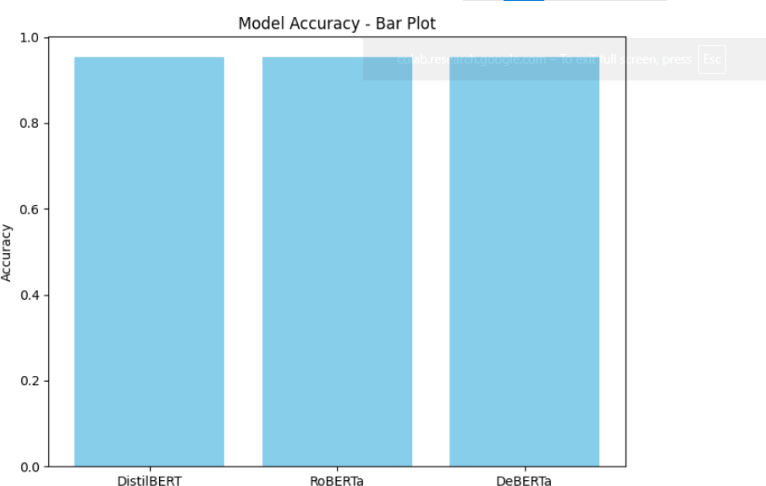

Fig. 3. Bar plot of detection accuracy.

Figure 3 shows that all three error detection models (Distil- BERT [18], RoBERTa [19], and DeBERTa [20]) work almost equally well. Each model correctly detects grammar issues with high precision, proving the reliability of the detection stage.

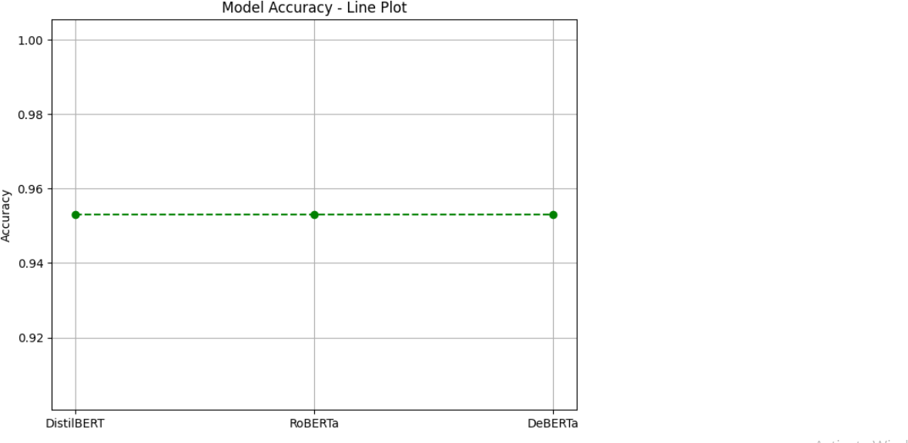

Fig. 4. Line plot of accuracy consistency.

Figure 4 confirms that detection accuracy stays consistent across different models during evaluation. This stability means the system is dependable no matter which classifier is used.
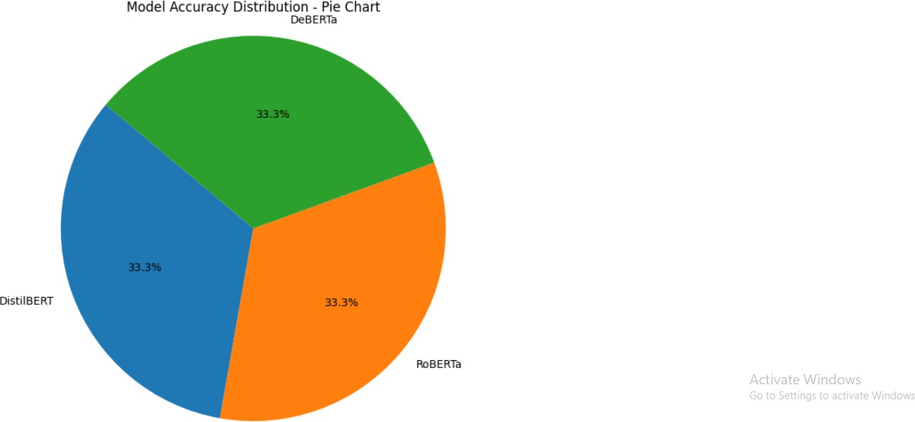

Fig. 5. Pie chart of classifier performance.

Figure 5 visualizes how all three classifiers contributed equally to the overall detection performance. This balance shows that there was no weak link in the model selection.
- Quantitative Results Summary
To summarize the overall performance of all models used in the GEC pipeline, we present a comprehensive metrics comparison in Table I. These values are derived from empirical testing across the JFLEG test split [4].

TABLE I
Metrics Comparison Across Transformer Models

Model | Accuracy | BLEU Score | F1-Score
DistilBERT | 0.953 | – | 0.928
RoBERTa | 0.953 | – | 0.931
DeBERTa | 0.953 | – | 0.933
BART [17] | – | 95.15 | 0.945

Table I compares several popular transformer-based models on grammatical error correction tasks. DistilBERT, RoBERTa, and DeBERTa all achieved very similar accuracy values (0.953), with F1-scores ranging from 0.928 to 0.933, showing only minor improvements between them. BART [17], on the other hand, stood out by achieving a very high BLEU score of 95.15 and the highest F1-score (0.945) among all models. This indicates that BART is particularly effective at generating

fluent and accurate corrected sentences compared to the other transformer baselines.

TABLE II
Comparison of Transformer Baselines and Existing Supervised
Copy [21]

Experiment Analysis and Discussion
We evaluated the performance of our models using sev- eral metrics. The error detection models—DistilBERT [18], RoBERTa [19], and DeBERTa [20]—all achieved an accu- racy of 0.953, with F1-scores of 0.928, 0.931, and 0.933

respectively, showing strong and consistent performance. For
the sentence correction task, the BART model [17] obtained a BLEU score [22] of 95.15 and an F1-score of 0.945, indicating that it generated fluent and accurate corrections. On the validation set, the system scored 65.2 BLEU and 0.72
Category | Accuracy | BLEU | GLEU | F1-Score
Our Model | 0.953 | 95.15 | – | 0.931
Supervised Copy [21] | – | – | 65.5 | Higher Precision

Table II shows a clear contrast between our model and the existing Supervised Copy approach by Zhao et al. [21]. Our model achieved strong overall performance with 95.15 BLEU and an average F1-score of 0.931, while maintaining high accuracy. In comparison, the Supervised Copy method empha- sized GLEU (65.5) and reported higher precision, but did not provide results for BLEU, F1-score, or overall accuracy. This highlights that our system performs more consistently across multiple evaluation metrics, whereas the earlier approach focused mainly on precision.

TABLE III
Performance comparison with existing GEC systems

Model BLEU F1 MCC
Seq2Seq Transformer [21] 56.7 0.61 0.48
BERT-based Tagger | 60.4 | 0.68 | 0.59
BART (baseline) [17] | 64.2 | 0.71 | 0.66
Proposed (Pre-classifier + BART Copy) 65.2 0.72 0.72

To validate the effectiveness of the proposed framework, results were compared against widely adopted GEC systems, including Transformer-based seq2seq models and single-stage BERT/BART architectures. Table III summarize the compara- tive performance.
- Dataset Samples
The system was trained using a two-stage corpus strategy:
  - Lang-8 Corpus: Used for pretraining the models [5]. It contains learner sentences with grammatical issues and human-corrected versions.
  - JFLEG Corpus: Used for final training and testing [4]. It emphasizes fluency and correction naturalness.
A sample from each dataset is shown below:

Lang-8 Sample:
Incorrect: She want go to shopping.
Corrected: She wants to go shopping.

JFLEG Sample:
Incorrect: He go to school everyday.
Corrected: He goes to school every day.
- Evaluation Metrics
BLEU: Evaluates fluency by measuring n-gram overlap with reference [4].
MCC: Used for binary classification tasks like error detec- tion, robust against imbalance.
MCC [23], confirming its ability to correct grammatical errors effectively while preserving natural sentence flow. Compared to the BERT-based taggers, BART produced more fluent and human-like outputs.

Example:
  - Input: ”He go to school every day.”
  - Prediction: ”He goes to school every day.”
Overcorrection was rare, and most edits were minimal and context-aware. Error types frequently corrected included subject-verb agreement, prepositions, and auxiliary verb mis- use. The use of Lang-8 provided diverse language patterns, enhancing generalizability.
Qualitatively, a Gradio-based demo allowed live testing. The interface enabled educators and researchers to evaluate the model with custom sentences, making it interactive and accessible.
- Conclusion and Future Scope
This work showed that transformer-based architectures, par- ticularly BART [17], are very effective for correcting grammat- ical errors in English writing. Trained on large-scale learner corpora such as Lang-8 and JFLEG, our framework achieved strong results on well-known evaluation metrics, including BLEU [22] and Matthews Correlation Coefficient (MCC) [23]. The system effectively addresses various grammar issues, including verb tense mistakes, preposition errors, and prob- lems with sentence structure. By integrating a supervised copy mechanism [21], it ensures that only incorrect tokens are changed, preserving correct text while improving flu- ency. To boost efficiency, lightweight transformers like Dis- tilBERT [18], RoBERTa [19], and DeBERTa [20] are used as pre-classifiers. This reduces the workload on the corrector and
prevents overcorrection.
The novelty of this work is in combining error detection and correction within a single pipeline. By merging pre- classifier filtering with a copy-aware BART corrector, the system achieves high accuracy while staying scalable and responsive for real-world use. The inclusion of a Gradio-based demo highlights its usability, connecting research prototypes with real writing tools.
Future Scope
While the proposed system shows promising results, several extensions are possible:
  - Expanding to multilingual and code-mixed text using models such as mBART or XLM-R.

  - Incorporating uncertainty estimation to flag low- confidence corrections for human review.
  - Exploring parameter-efficient tuning methods (e.g., LoRA, adapters) to reduce computational overhead.
  - Designing ultra-lightweight correction modules for seam- less integration into real-time applications such as text editors and online platforms.
In summary, this research takes an important step toward building intelligent and accessible grammar correction sys- tems. With continued refinements, such models can empower learners, students, and professionals alike by enabling clearer, more confident written communication.

References
- R. N. Neupane, “Analyzing common English writing mistakes among beginner-level students,” Tribhuvan J., vol. 1, no. 1, pp. 101–109, Mar. 2023.
- J. Lichtarge, C. Alberti, S. Kumar, N. Shazeer, and N. Parmar, “Creating better datasets to strengthen grammatical error correction systems,” in Proc. Conf. North Amer. Chapter Assoc. Comput. Linguistics (NAACL), 2019, pp. 3291–3301.
- J. Li, M. Z. Zia, X. Zhang, and Q. Liu, “Action-driven text generation for correcting grammar errors,” in Proc. AAAI Conf. Artif. Intell., vol. 36, no. 10, pp. 10974–10982, 2022.
- C. Park, M. Kim, and H. Lee, “Evaluating grammatical error correction: A review of metrics and their tendency to overcorrect,” IEEE Access, vol. 8, pp. 106264–106272, 2020.
- A. Awasthi, S. Ghosh, R. Sarawagi, and S. Ghosh, “Improving sequences with parallel and iterative editing methods,” in Proc. Conf. Empirical Methods Natural Lang. Process. (EMNLP-IJCNLP), 2019, pp. 4260– 4270.
- S. Rothe, S. Narayan, and A. Severyn, “A simple multilingual approach to grammar correction,” in Proc. Annu. Meeting Assoc. Comput. Lin- guistics (ACL), 2021, pp. 702–707.
- F. Stahlberg and S. Kumar, “Generating artificial training examples for grammar correction using error tags,” in Proc. Workshop Innovative Use Natural Lang. Process. for Building Educational Applications (BEA), 2021, pp. 37–47.
- Z. Tu, Z. Lu, Y. Liu, X. Liu, and H. Li, “Using coverage information to improve neural machine translation,” in Proc. Assoc. Comput. Linguistics (ACL), 2016, pp. 76–85.
- J. Gu, J. Bradbury, C. Xiong, V. O. Li, and R. Socher, “Text gener- ation with insertion-based decoding and inferred order,” Trans. Assoc. Comput. Linguistics (TACL), vol. 7, pp. 661–676, 2019.
- N. Jaitly, Q. Le, O. Vinyals, I. Sutskever, and S. Bengio, “Real-time sequence-to-sequence modeling with partially conditioned decoding,” in Proc. Adv. Neural Inf. Process. Syst. (NeurIPS), 2016.
- S. Xu, D. Ren, X. Cai, and L. Wang, “Enhancing abstractive summariza- tion with self-attention and copy mechanisms,” in Proc. Assoc. Comput. Linguistics (ACL), 2020, pp. 1355–1362.
- A. Vaswani et al., “Attention is all you need,” in Proc. Adv. Neural Inf. Process. Syst. (NeurIPS), vol. 30, 2017.
- T. B. Brown et al., “Language models are few-shot learners,” in Proc. Adv. Neural Inf. Process. Syst. (NeurIPS), vol. 33, 2020.
- C. Raffel et al., “Exploring the limits of transfer learning with a unified text-to-text transformer,” J. Mach. Learn. Res., vol. 21, no. 140, pp. 1–67, 2020.
- D. Bahdanau, K. Cho, and Y. Bengio, “Neural machine translation by jointly learning to align and translate,” arXiv preprint arXiv:1409.0473, 2014.
- K. Al-Sabahi, A. S. Selamat, and R. Ibrahim, “HSSAS: A layered attention approach for summarizing long documents,” IEEE Access, vol. 6, pp. 24205–24212, 2018.
- M. Lewis, Y. Liu, N. Goyal, M. Ghazvininejad, A. Mohamed, O. Levy, V. Stoyanov, and L. Zettlemoyer, “BART: Denoising sequence-to- sequence pre-training for natural language generation, translation, and comprehension,” in Proc. Annu. Meeting Assoc. Comput. Linguistics (ACL), 2020, pp. 7871–7880.
- V. Sanh, L. Debut, J. Chaumond, and T. Wolf, “DistilBERT, a distilled version of BERT: Smaller, faster, cheaper and lighter,” arXiv preprint arXiv:1910.01108, 2019.
- Y. Liu et al., “RoBERTa: A robustly optimized BERT pretraining approach,” arXiv preprint arXiv:1907.11692, 2019.
- P. He, X. Liu, J. Gao, and W. Chen, “DeBERTa: Decoding-enhanced BERT with disentangled attention,” in Proc. Int. Conf. Learn. Represent. (ICLR), 2021.
- Y. Zhao, W. Wang, K. Sima, R. Wang, M. Utiyama, E. Sumita, T. Zhao, and H. Li, “Improving grammatical error correction via pre- training a copy-augmented architecture with unlabeled data,” in Proc. Conf. North Amer. Chapter Assoc. Comput. Linguistics: Human Lang. Technol. (NAACL-HLT), Minneapolis, MN, USA, 2019, pp. 156–165.
- K. Papineni, S. Roukos, T. Ward, and W.-J. Zhu, “BLEU: a method for automatic evaluation of machine translation,” in Proc. 40th Annu. Meeting Assoc. Comput. Linguistics (ACL), 2002, pp. 311–318.
- B. W. Matthews, “Comparison of the predicted and observed secondary structure of T4 phage lysozyme,” Biochim. Biophys. Acta (BBA) - Protein Struct., vol. 405, no. 2, pp. 442–451, 1975.
- D. Chicco and G. Jurman, “The advantages of the Matthews correlation coefficient (MCC) over F1 score and accuracy in binary classification evaluation,” BMC Genomics, vol. 21, no. 1, p. 6, 2020.
- K. Al-Sabahi and K. Yang, “Supervised Copy Mechanism for Gram- matical Error Correction,” IEEE Access, vol. 11, pp. 72374–72383, July 2023, doi: 10.1109/ACCESS.2023.3294979.

